In programming languages like C and C++, the code is first compiled into platform-specific machine code. These languages are called compiled languages.

On the other hand, in languages like JavaScript and Python, the computer executes the instructions directly without having to compile them.
converts each high-level program statement into machine code .These languages are called interpreted languages.

Java uses a combination of both techniques. Java code is first compiled into byte code to generate a class file. This class file is then interpreted by the Java Virtual Machine for the underlying platform. The same class file can be executed on any version of JVM running on any platform and operating system.

Similar to virtual machines, the JVM creates an isolated space on a host machine. This space can be used to execute Java programs irrespective of the platform or operating system of the machine.

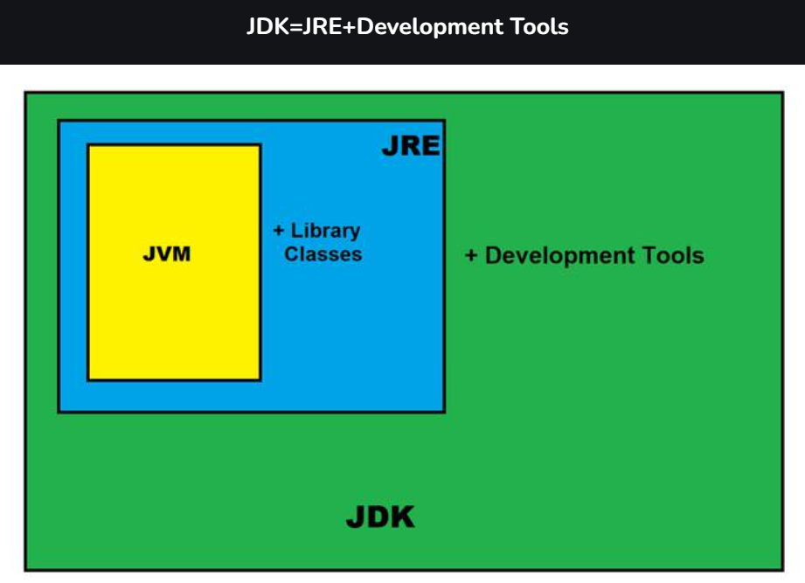

JRE

It is the implementation of JVM. It physically exists. It contains a set of libraries + other files that JVM uses at runtime.
The Java Development Kit (JDK) is a software development environment which is used to develop Java applications and applets. It physically exists. It contains JRE + development tools.
The JDK contains a private Java Virtual Machine (JVM) and a few other resources such as an interpreter/loader (java), a compiler (javac), an archiver (jar), a documentation generator (Javadoc), etc. to complete the development of a Java Application.
JDK contains:
- Private JVM,
- An interpreter/loader (Java),
- A compiler (javac),
- An archiver (jar), Documentataion generator(Javadoc) etc.

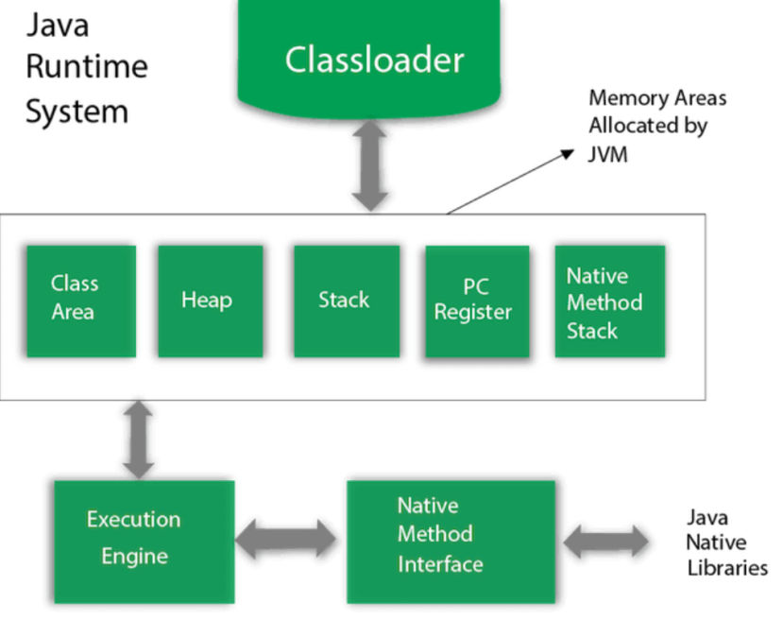

1) Classloader
Classloader is a subsystem of JVM which is used to load class files. Whenever we run the java program, it is loaded first by the classloader. There are three built-in classloaders in Java.
- Bootstrap ClassLoader (Parent)
Loads core Java classes
- Extension ClassLoader
Sits between Bootstrap and Application ClassLoader
- Application (System) ClassLoader (Child)
Loads classes from CLASSPATH && User-defined classes & Project classes

ClassLoader Delegation Model
How delegation works:
Application ClassLoader receives a request
It delegates to Extension ClassLoader
Extension delegates to Bootstrap ClassLoader
If parent finds class → returns
If parent doesn’t find → child tries
Parent-first approach

Class loading follows Parent → Child delegation

Why delegation is important?
Security
Prevents overriding core Java classes
Ensures consistency of Java runtime
Without delegation core class like java.lang.String // could be replaced by malicious class

Why can’t we override java.lang.String?
java.lang.String is loaded by Bootstrap ClassLoader
Bootstrap is always checked first
Your custom String class is ignored
This prevents breaking the JVM

How to Check Which ClassLoader Loaded a Class
public class ClassLoaderTest {
public static void main(String[] args) {
System.out.println(String.class.getClassLoader());
System.out.println(ClassLoaderTest.class.getClassLoader());
} }
-> ClassName.class.getClassLoader();

Custom ClassLoader
Load classes from:
Encrypted files
Network
Dynamic plugins
Used in:
Application servers
Frameworks (Spring, Tomcat)

ClassNotFoundException Occurs when:
Class is not in classpath
ClassLoader cannot locate it at runtime

2) Class(Method) Area
Class(Method) Area stores per-class structures such as the runtime constant pool, static fields and method data, the code for methods and class metadata.

3) Heap
The Heap is the runtime memory area where all Java objects and arrays are stored.
It is shared across all threads.
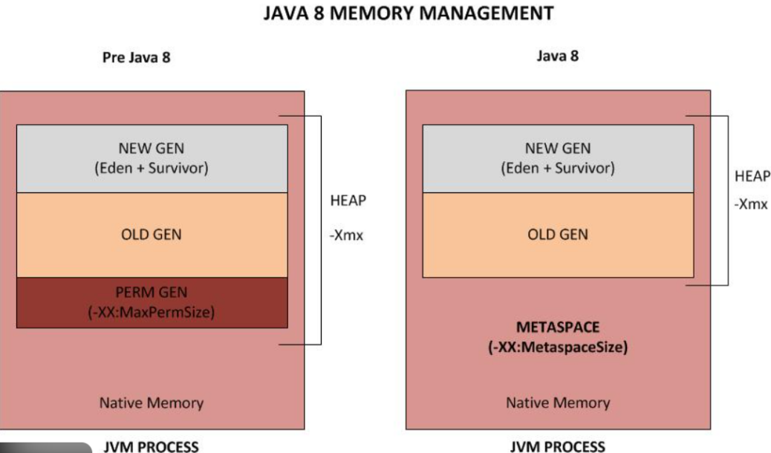

JVM Heap Structure

Heap Memory Areas
1.Young Generation
Stores newly created objects && Designed for fast allocation & fast garbage collection
- Eden Space
First place where objects are created
Most objects die here
Minor GC happens frequently
- Survivor Space (S0, S1)
Two small memory areas
Used to store objects that survived Minor GC
Objects move back and forth between S0 and S1
Why two survivor spaces?
To avoid memory fragmentation (Memory fragmentation means free memory exists, but it is broken into small, non-contiguous pieces, so large objects cannot be allocated efficiently.)
One is From, other is To
2.Old Generation (Tenured)
Stores long-lived objects
Objects promoted after surviving multiple GCs
Examples: Cached objects && Session-related objects.
Garbage Collection here is: Major GC / Full GC
GC triggers When memory becomes full.
- Metaspace (Java 8+)
Stores:
Class metadata
Method metadata
Runtime constant pool
Static variables (class-level)
Key points:
Uses native memory, not heap
Grows dynamically
Less OutOfMemoryError compared to PermGen
Metaspace is an implementation of Method Area
you can say conceptually becoz of same features.

Object Allocation Flow

Normal Lifecycle of an Object
Object created → Eden
Minor GC runs
Surviving objects → Survivor S0
Next GC → moves to S1
After multiple survivals → Old Generation

Why Most Objects Die Young
Real-world applications create many:
Temporary objects
Loop variables
Method-local objects
Request/response objects
These are:
Created quickly
Used briefly
Then become unreachable
➡ JVM optimizes GC for this behavior

Why are most objects created in Eden space?
Because most objects in Java applications are short-lived.
Eden space allows fast allocation and quick garbage collection using Minor GC, making memory management more efficient and helps performance.

4) Stack
Java Stack stores frames. It holds local variables and partial results, and plays a part in method invocation and return.
Each thread has a private JVM stack, created at the same time as thread.
A new frame is created each time a method is invoked. A frame is destroyed when its method invocation completes.
• Stores:
Method frames
Local variables
References
• Memory freed as soon as method exits
• Each thread has its own stack

Heap
• Stores:
Objects
Arrays
Class-level data
• Shared across threads
• Cleaned by Garbage Collector

Stack | Heap
Thread-specific | Shared among threads
Stores local variables | Stores objects
Fast access | Slower
Auto cleaned | GC cleaned
StackOverflowError | OutOfMemoryError

void test() {
int x = 10; // Stack
User u = new User(); // reference → Stack, object → Heap
}
Why is stack faster than heap?
Stack is faster because it uses simple LIFO allocation, is thread-local, does not require synchronization or garbage collection, and memory is allocated and freed automatically during method calls.

5) Program Counter Register
PC (program counter) register contains the address of the Java virtual machine instruction currently being executed.

Key Points
Each thread has its own PC Register
Stores the address of the current bytecode instruction
Helps JVM resume execution after context switching
(Context switching is the process where the CPU stops executing one process/thread and switches to another, saving the current state and loading the next one.)
Very small in size
Created when a thread starts
Destroyed when the thread ends

For native methods, PC Register value is undefined

What happens with native methods?
native void doNative();
Implemented in C / C++
Executed via JNI
Runs outside the JVM bytecode engine
JVM does not control instruction execution
So no bytecode address to track
Therefore:
PC register has no meaningful value
JVM specification says: PC is undefined

Why PC Register is Needed?
Java supports multithreading.
When CPU switches between threads:
JVM uses PC Register to remember where each thread stopped
Execution resumes from the exact next instruction

6) Native Method Stack

The Native Method Stack is a JVM runtime data area used to execute native (non-Java) methods written in languages like C or C++.

JNI → Bridge between Java and native languages
Used for JNI (Java Native Interface) calls
Each thread has its own Native Method Stack
Stores:
Native method execution data
Local variables of native methods
Native call frames
Created when thread starts
Destroyed when thread ends
Works separately from Java Stack

7) Execution Engine
It contains:
- A virtual processor
- Interpreter: Read bytecode stream then execute the instructions.
- Just-In-Time(JIT) compiler: JIT Compiler converts frequently executed bytecode into native machine code at runtime.

Key Points :
Converts frequently executed bytecode into native machine code
Improves overall application performance
Avoids repeated interpretation
Happens at runtime, not compile time
Native code is reused
- GC
Why does JIT improve Java performance
JIT improves Java performance by compiling frequently executed bytecode into native machine code, which avoids repeated interpretation and allows faster execution

8) Java Native Interface
Java Native Interface (JNI) is a framework which provides an interface to communicate with another application written in another language like C, C++, Assembly etc. Java uses JNI framework to send output to the Console or interact with OS libraries.

Java Syntax

public class Main {
public static void main(String[] args) {
System.out.println("Hello World");
}
}

How to run with cmd =>
C:\Users\Your Name>javac Main.java
C:\Users\Your Name>java Main

Execution Flow:
ClassLoader Subsystem
Loads .class files into memory.
Loaded classes are stored in the Class Area.
JVM Memory Areas
Class Area (Method Area): Stores class metadata, bytecode, static variables.
Heap: Stores objects and instance variables (shared across threads).
Stack: Stores method calls and local variables (one stack per thread).
PC Register: Holds the address of the current instruction.
Native Method Stack: Supports native (C/C++) method execution.
Execution Engine
Executes bytecode using:
Interpreter (line-by-line execution)
JIT Compiler (converts reguarly used bytecode to native code for performance)
Works with data from Heap, Stack, and Class Area.
JNI (Java Native Interface)
Enables Java code to interact with native libraries.
Java Native Libraries
Platform-specific libraries used by native methods.
Program Termination
JVM shuts down when all non-daemon threads complete execution.
In Java, every application begins with a class name, and that class must match the filename.
A class should always start with an uppercase first letter.
Java is case-sensitive: "MyClass" and "myclass" has different meaning.

Java Variables
In Java, there are 5 different types of variables, for example:
String
int -
float - stores floating point numbers, with decimals, such as 19.99 or -19.99 float mynum = 5.99f; double mynum =19.99d;
char -
boolean -

Data types are divided into two groups:
- Primitive data types - includes byte, short, int, long, float, double, boolean and char
- Non-primitive data types - such as String, Arrays and Classes (you will learn more about these in a later chapter)
Non-primitive data types are called reference types because they refer to objects.
A primitive data type specifies the size and type of variable values, and it has no additional methods.
A primitive type has always a value, while non-primitive types can be null.
A primitive type starts with a lowercase letter, while non-primitive types starts with an uppercase letter.

Java Type Casting
Type casting is when you assign a value of one primitive data type to another type.
In Java, there are two types of casting:
- Widening Casting (automatically) - converting a smaller type to a larger type size
byte -> short -> char -> int -> long -> float -> double
- Narrowing Casting (manually) - converting a larger type to a smaller size type
double -> float -> long -> int -> char -> short -> byte
int myInt = (int) myDouble; // Manual casting: double to int

System.out.print() => will print in same line
System.out.println() => always prints in newline
\n => for new line

- Math.max(x,y)
- Math.min(x,y)
- Math.abs(x)
- Math.sqrt(x)
- Math.random()

The Math.abs(x) method returns the absolute (positive) value
Math.random() returns a random number between 0.0 (inclusive), and 1.0 (exclusive)
% -> modules operator , gives reminder when divided.

ternary operator

variable = (condition) ? expressionTrue : expressionFalse;

For-Each Loop
String[] cars = {"Volvo", "BMW", "Ford", "Mazda"};
for (String i : cars) {
System.out.println(i);
} //use forEach loop to access and read data , use normal for loop for any operation on data inside loop.

for-loop | for-each
Index access | No index
Can modify elements | Read-only
More control | Cleaner syntax

Java Switch Statements
int day = ;
switch (day) {
case 6:
System.out.println("Today is Saturday");
break;
case 7:
System.out.println("Today is Sunday");
break;
default:
System.out.println("Looking forward to the Weekend");}

Java User Input
The Scanner class is used to get user input, and it is found in the java.util package.
To use the Scanner class, create an object of the class and use any of the available methods found in the Scanner class documentation. In our example, we will use the nextLine() method, which is used to read Strings:
import java.util.Scanner; // Import the Scanner class
import java.util.*;

class Main{
public static void main(String[] args){
System.out.println("Hi");
Scanner sc = new Scanner(System.in);
String name;
System.out.println("Enter your Name");
name = sc.nextLine();

System.out.println("Your Name is: " + name);

}
}
nextInt() = for taking next int as input.

String to int
String str1 = "5";
int result = Integer.parseInt(str1); // Using Integer.parsrInt()
System.out.println(result);

Int to String
int x = 5;
//2nd way ( use this mostly)
String str2 = String.valueOf(x); // using String.valueOf()
System.out.println(str2);

Documention Comments
The documentation comments are placed between /** and */.

Java Garbage Collection
In java, garbage means unreferenced objects.
Garbage Collection is process of reclaiming the runtime unused memory automatically. In other words, it is a way to destroy the unused objects.
To do so, we were using free() function in C language and delete() in C++. But, in java it is performed automatically. So, java provides better memory management.
In Java, the garbage collector runs automatically to free memory by identifying objects that are no longer referenced. When an object is eligible for garbage collection, the JVM may call its finalize() method just before actually collecting it. After that, the memory is reclaimed and the object is removed from the heap.

Garbage Collection Types

Types of GC
Minor GC → Young Generation
Cleans :
Eden
Survivor spaces (S0, S1)
Happens frequently

Major GC → Old Generation
Runs on Old Generation
Cleans long-lived objects
Happens less frequently

Full GC → Entire Heap
Runs on Entire Heap
Young Gen
Old Gen
Metaspace (in many cases)
Long pause times

Stop-the-World
All application threads pause during GC
During GC:
All application threads are paused
JVM performs GC safely
After GC, threads resume

GC Algorithm

Basic GC Phases

Mark
JVM identifies reachable objects
Objects still in use are marked alive

Sweep
Unmarked (dead) objects are removed
Memory is freed

Compact
Remaining objects are moved together
Removes memory gaps
Updates object references
Improves allocation speed

Why does GC impact application performance?
GC impacts performance because during garbage collection the JVM pauses application threads (Stop-the-World), consumes CPU cycles, and may move objects in memory, which increases latency.

Applications are designed so that most objects die young, keeping GC mostly in Minor GC. Performance problems usually appear when objects get promoted too fast to Old Generation, causing Major or Full GC.

How can an object be unreferenced?
There are many ways:
- By nulling the reference
- By assigning a reference to another
- By anonymous object etc.

The finalize() method is invoked each time before the object is garbage collected. This method can be used to perform cleanup processing.
The gc() method is used to invoke the garbage collector to perform cleanup processing
What is finalize()?
finalize() is a method defined in java.lang.Object.
It was meant to allow an object to clean up resources (like closing files or releasing memory) before the object is garbage collected.
finalize() is deprecated (Java 9+)
Interviewers may ask:
“Why should finalize() not be used?”
You should add:
finalize() is unreliable
No guarantee when it runs
Use try-with-resources / AutoCloseable instead

What Is Memory Leak?
Objects are still referenced but never used
GC cannot reclaim referenced objects

Common Causes
Static collections holding objects
Unclosed resources
Event listeners not removed
Caches growing infinitely
How can memory leak happen in Java despite GC
Memory leak happens in Java when objects are no longer used but are still referenced. Since Garbage Collector only removes unreachable objects, it cannot reclaim these referenced objects, causing memory leak despite GC.
Common JVM Errors

OutOfMemoryError (OOME)
Thrown when JVM cannot allocate more memory, even after running Garbage Collection.

Common causes:
Memory leaks
Heap size too small
Infinite object creation
Metaspace exhaustion

StackOverflowError
Occurs when stack memory is exhausted, usually due to deep or infinite recursion.
void recurse() {
recurse(); // infinite recursion
}
Key point:
Each method call adds a stack frame
Too many calls → stack limit exceeded

ClassNotFoundException vs NoClassDefFoundError

ClassNotFoundException
Checked exception
Occurs at runtime
JVM cannot find the class in classpath
Usually occurs when loading class dynamically

NoClassDefFoundError
Error, not exception
Occurs at runtime
Class was present at compile time
But missing or failed to load at runtime
Common reasons:
Missing JAR at runtime
Class initialization failure
Version mismatch

Difference between ClassNotFoundException and NoClassDefFoundError?
ClassNotFoundException occurs when a class is not found in the classpath at runtime, usually during dynamic class loading.
NoClassDefFoundError occurs when the class was available at compile time but is missing or cannot be loaded at runtime.

Lets Recall
- How java works vs other language
- Explain all jdk
- What are jdk contains
- Explain java runtime system.
- Classloader and delegation model
- Explain heap and internal workings.
- Heap vs stack explain.
- Pc register explain.
- JMS and JNI.
- Execution engine and overall process of a program.
- What are data types and primitive vs non primitive
- Java user input write code
- Type Casting Sequence
- Int to string and vice versa (code)
- How GC works and explain types , stop the world and gc algorithms
- What is finalize method and why deprecated.
- Commans JVM Errors

